# Assignment Submission

## Coding for Designers, Managers, and Entrepreneurs III

Chris Harwood

# 

# Part 1: User Stories

## User Stories

**Epic 6** – Update the Home page**: As a** technician, **I want** the ability to log into the HVAC In a Hurry site **so that** I can be authenticated, allowing me to use the functionality provided by the site.

* *Story 1:* **As a** technician, **I want** the ability to register on the HVAC In a Hurry site using my company email and a personal password **so that** I will be able to use the site.
* *Story 2:* **As a** technician, **I want** the ability to log onto the HVAC In a Hurry site using my company email and a personal password **so that** I can use the site.
* *Story 3:* **As a** website, **I want** to restrict access to the Home page and the Help page only to those not logged in **so that** unauthorized users don’t have access to proprietary company information.

**Epic 7** – Update the Search page for the technicians: **As a** technician, **I want** to see a dynamic list of all parts **so that** I can choose from the most current and comprehensive offerings.

* *Story 1:* **As a** website, **I want** to dynamically obtain the current parts offered **so that** I present a comprehensive list to the tech.

**Epic 8** – Update the Parts page for the technicians: **As a** technician, **I want** to see detailed information on all parts **so that** I can clarify price and availability to my customer

* *Story 1:* **As a** website, **I want** to dynamically obtain the current part details, shown upon clicking a specific part on the Search page, **so that** I can present comprehensive part information to the tech.

*Note: For Epic 8, the only ‘part’ coded to display is the Sniggler Board for Acme Cooler. Functionality to open corresponding parts will be a future story.*

# Part 2: Prototypes

Epic 6

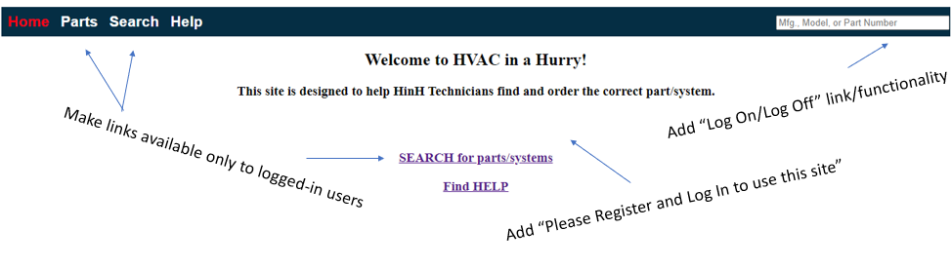

*Note on Epic 6: Once logged in a user has access to the links to the Parts and Search pages. However, if they navigate to either of these pages, their log-on information is currently lost – this will be addressed in a future release.*

# Part 3: Links to JS Fiddle

## Links to ~~JS Fiddle(s)~~ Github

<https://mnchsplat.github.io/Coding-For-MGRs-III/>

Note – my solution requires 4 html files (index, search, help, part_details), so instead of JSFiddle, have uploaded them to my Github site. The URL provided will present my complete solution for this course, supporting the Epics and user stories, above.

For these stories, please review the script.js and search.html files via Chrome Inspect (click each file on the Sources tab to view). I updated lines 65-67 in Search.html, added (and modified) code on lines 128-332 in script.js for firebase logging on/off functionality, and added/modified code on lines 376-456 in script.js to handle the load/display of parts on the Search Page.